Bahria University,

Karachi Campus



LAB EXPERIMENT NO.

**05**

LIST OF TASKS

|  |  |
| --- | --- |
| TASK NO | OBJECTIVE |
| 1 | **Using the Shopping List files from the previous videos update the shopping list app to do the following: A. If you click on the list item, it toggles the. done class on and off. B. Add buttons next to each list item to delete the item when clicked on its corresponding delete button. C. BONUS: When adding a new list item, it automatically adds the delete button next to it** |
| 2 | **Write a JavaScript program to calculate the volume of a sphere.** |
| 3 | **Create a webpage that ask user to perform any of the following operations Generate Table: Write a script to generate table, prompt**  **user to enter a number for Which the user wants to create a table Generate Number Sequence: Write a script to generate**  **sequence of numbers, prompt user to enter a limit up to**  **Which they want to generate sequence of numbers. Calculate power: Write a script to calculate power of a number. Ask user to enter the of base and exponent. Calculate and display the result. Generate Even / Odd No. Sequence: Prompt user to enter their choice for men NO or Odd NO and display the results accordingly for the sequence** |
| 4 | **Create a document with multiple tabs with background color. Upon hover background color of the document is changed accordingly** |

**Task 01: Using the Shopping List files from the previous videos update the shopping list app to do the following:  
A. If you click on the list item, it toggles the. done class on and off.  
B. Add buttons next to each list item to delete the item when clicked on its corresponding delete button. C. BONUS: When adding a new list item, it automatically adds the delete button next to it**

**Solution:**

**Index.html**

  <main>

        <nav>

            <ul class="navi" style="list-style: none;display: flex;justify-content: space-evenly;">

                <a href="task1.html" style="text-decoration:none">

                    <li>Todo App</li></a>

                <a href="task2.html" style="text-decoration:none">

                    <li>Volume of a sphere</li></a>

                <a href="task3.html" style="text-decoration:none">

                    <li>Multiple Operations</li></a>

                <a href="task4.html" style="text-decoration:none">

                    <li>Background-Color Tabs</li>

</a></ul></nav></main>

**Task1.html**

 <main>

        <section>

            <div class="main">

                <div class="child">

                    <div class="children">

                        <h1 class="heading" style="color: white;">

                            To Do List</h1></div>

                    <div class="children">

                        <input type="text" class="same" id="input" placeholder="Enter Item">

                        <button id="btn" class="same">+</button></div>

                    <div class="main2">

                        <div class="child2">

                            <ul id="list" style="color: white;">

                            </ul></div></div></div></div>

</section> </main>

**Task1.js**

var a=document.getElementById("input");

var b=document.getElementById("btn");

var c=document.getElementById("list");

var deletebutton=document.getElementById('delete');

b.addEventListener('click',function(){

  console.log('workingenter')

    if(a.value.length>0)

    {

      var li=  document.createElement("li");

      var button = document.createElement('input');

        button.setAttribute('type', 'button');

        button.setAttribute('ID', 'delete');

        button.setAttribute('value', "x");

        button.setAttribute('onclick', "deleted(this)");

      li.appendChild(document.createTextNode(a.value));

      c.appendChild(li);

      li.appendChild(button);

      a.value='';

    }})

   function deleted(x)

    {

      x.parentElement.remove();

    }

a.addEventListener('keypress',function(event){

  console.log('workinginput')

    if(a.value.length>0 && event.keyCode===13)

    {

      console.log('working')

        var button = document.createElement('input');

        button.setAttribute('type', 'button');

        button.setAttribute('ID', 'delete');

        button.setAttribute('value', 'Delete');

      var li=  document.createElement("li");

      li.appendChild(document.createTextNode(a.value));

      c.appendChild(li);

      li.appendChild(button);

      a.value=''; }})

**Output:**

**Task 2: Write a JavaScript program to calculate the volume of a sphere.**

**Solution:**

**Task2.html**

<main>

        <section>

            <div class="main">

                <div class="child">

                    <div class="children">

                        <label for="" class="same" style="font-size: 20px;color: white;"><b>Radius</b></label>

                        <input type="number" id="input" class="same" placeholder="Enter Radius Number">

                        <label for="" class="same" style="font-size: 20px;color: white;"><b>Volume</b></label>

                        <input type="number" id="input2" class="same" placeholder="Enter Volume Number">

                        <input style="color: white;" type="button" id="btn" class="same" value="Calculate">

                    </div></div></div>

        </section></main>

**Task2.js**

var radius=document.getElementById("input")

var volume=document.getElementById("input2")

var calculate=document.getElementById("btn")

calculate.addEventListener("click",function(){

    if(radius.value>0)

    {

        volume.value=(4*Math.PI*Math.pow(radius.value,3))/3;

        radius.value="";

    }

   else if(radius.value=='')

    {

        volume.value="";

        radius.value="";}})

**Output:**

**Task 3: Create a webpage that ask user to perform any of the following operations Generate Table: Write a script to generate table, prompt**

**user to enter a number for Which the user wants to create a table**

**Generate Number Sequence: Write a script to generate**

**sequence of numbers, prompt user to enter a limit up to**

**Which they want to generate sequence of numbers.   
Calculate power: Write a script to calculate power of a number. Ask user to enter the of base and exponent. Calculate and display the result.   
Generate Even / Odd No. Sequence: Prompt user to enter their choice for men NO or Odd NO and display the results accordingly for the sequence**

**Solution:**

**Task3.html**

 <main>

        <nav>

            <ul class="navi" style="list-style: none;display: flex;justify-content: space-evenly;">

                <a href="task3/task1.html" style="text-decoration:none">

                    <li>Genarate Table</li>

                </a>

                <a href="task3/task2.html" style="text-decoration:none">

                    <li>Generate Number Sequence</li>

                </a>

                <a href="task3/task3.html" style="text-decoration:none">

                    <li>Calculate Power</li>

                </a>

                <a href="task3/task4.html" style="text-decoration:none">

                    <li>Genarate Even/Odd Number Sequence</li>

                </a>

            </ul></nav></main>

**Output:**



**Task 3 => Task1.html**

 <main>

        <div class="box">

            <div class="child">

                <div class="children">

                    <label for="" class="same" style="color: white;font-size: large;"><b>Table</b></label>

                    <input type="number" id="table" class="same" placeholder="Enter Number">

                    <button style="color: white;" id="btn" class="same">Generate</button>

                </div>

                <div class="box tableprint" style="color: white;">

                </div></div></div>

</main>

**Task1.js**

var nmber=document.getElementById("table")

var generate=document.getElementById("btn")

var print=document.getElementsByClassName("tableprint")[0]

generate.addEventListener("click",function(){

    if(nmber.value=="")

    {

        print.remove();

        window.location.reload()

    }

    else if(nmber.value>0)

    {

        for(var i=1;i<=10;i++)

        {

            var x = document.createElement("div");

            x.setAttribute('ID', 'arrange');

            x.textContent =`${nmber.value} * ${i} = ${nmber.value*i}`

            print.appendChild(x);

        }

    }

    nmber.value="";})

**Output:**

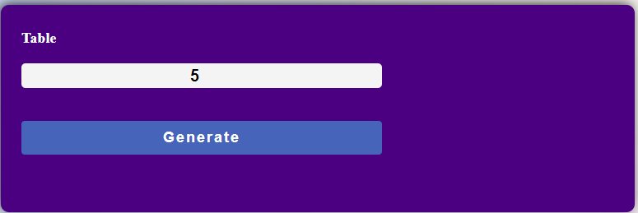

**Task 3 => Task2.html**

 <main>

        <div class="box">

            <div class="child">

                <div class="children">

                    <label for="" class="same" style="color: white;font-size: large;"><b>Number Sequence</b></label>

                    <input type="number" id="table" class="same" placeholder="Enter A Limit ">

                    <button style="color: white;" id="btn" class="same">Generate Sequence</button>

                </div>

                <div class="box tableprint" style="color: white;">

                </div></div></div>

</main>

**Task2.js**

var nmber=document.getElementById("table")

var generate=document.getElementById("btn")

var print=document.getElementsByClassName("tableprint")[0]

generate.addEventListener("click",function(){

    if(nmber.value=="")

    {

        print.remove();

        window.location.reload()

    }

    else if(nmber.value>0)

    {

        for(var i=0;i<=nmber.value;i++)

        {

            var x = document.createElement("div");

            x.setAttribute('ID', 'arrange');

            x.textContent =`${i}`

            print.appendChild(x);} }

    nmber.value="";})

**Output:**

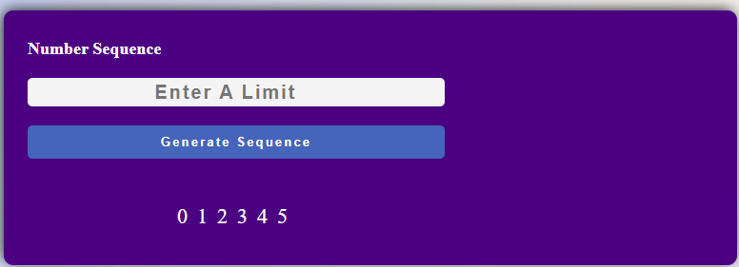

**Task 3 => Task3.html**

<main>

        <div class="box">

            <div class="child">

                <div class="children">

                    <label for="" class="same" style="color: white;font-size: large;"><b>Base</b></label>

                    <input type="number" id="base" class="same" placeholder="Enter Base ">

                    <label for="" class="same" style="color: white;font-size: large;"><b>Power</b></label>

                    <input type="number" id="power" class="same" placeholder="Enter Power ">

                    <br>

                    <button style="color: white;" id="btn" class="same" >Calculate Power </button>

                    <label for="" class="same" style="color: white;font-size: large;"><b>Result</b></label>

                    <input type="number" id="result" class="same" placeholder="Result ">

                </div>

                <div class="box tableprint" style="color: white;">

                </div></div></div></main>

**Task3.js**

var base=document.getElementById("base")

var powe=document.getElementById("power")

var btn=document.getElementById("btn")

var result=document.getElementById("result")

btn.addEventListener("click",function(){

    if(base.value>0 && powe.value>0)

    {

        result.value=(Math.pow(base.value,powe.value));

        base.value="";

        powe.value="";

    }

   else if(base.value=='' || powe.value=="")

    {

        base.value="";

        powe.value="";

        result.value="";}})

**Output:**

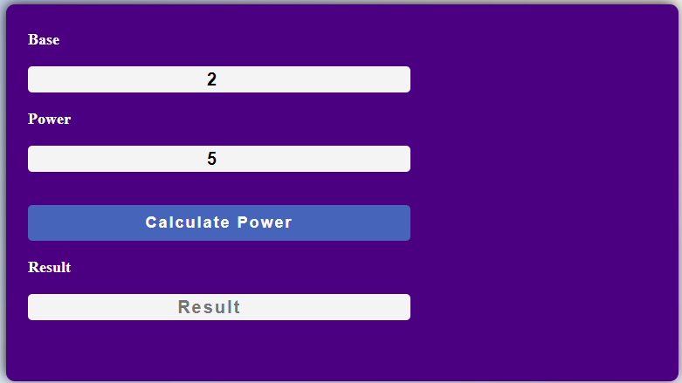

**Task 3 => Task4.html**

 <main>

        <div class="box">

            <div class="child">

                <div class="children">

                    <label for="" class="same" style="color: white;font-size: large;"><b>Number Sequence Even/Odd</b></label>

                    <input type="text" id="table" class="same" placeholder="Enter E or O ">

                    <button style="color: white;" id="btn" class="same" >Generate Sequence For Even/Odd</button>

                </div>

                <div class="box tableprint" style="color: white;">

                </div></div></div>

    </main>

**Task4.js**

var nmber=document.getElementById("table")

var generate=document.getElementById("btn")

var print=document.getElementsByClassName("tableprint")[0]

generate.addEventListener("click",function(){

    if(nmber.value=="")

    {

        print.remove();

        window.location.reload()

    }

     if(nmber.value.length>0)

    {

        if(nmber.value=='E' || nmber.value=='e')

        {

            for(var i=0;i<=20;i=i+2)

            {

                var x = document.createElement("div");

                x.setAttribute('ID', 'arrange');

                x.textContent =`${i}`

                print.appendChild(x);

            }

        }

       else  if(nmber.value=='O' || nmber.value=='o')

        {

            for(var i=1;i<=20;i=i+2)

            {

                var x = document.createElement("div");

                x.setAttribute('ID', 'arrange');

                x.textContent =`${i}`

                print.appendChild(x);}}}

    nmber.value="";})

**Output:**

**Task 4: Create a document with multiple tabs with background color. Upon hover background color of the document is changed accordingly**

**Solution:**

**Task4.html**

 <main>

       <div class="container" style="margin-top: 50px;">

            <div class="main" >

                <div class="CH box1" onmouseenter="colorchangeyellow()" onmouseleave="colorsame()">

                    <h2>M</h2>

                </div>

                <div class="CG box1" onmouseenter="colorchangered()" onmouseleave="colorsame()">

                    <h2>U</h2>

                </div>

                <div class="CI box1" onmouseenter="colorchangegreen()" onmouseleave="colorsame()">

                    <h2>A</h2>

                </div>

                <div class="CP box1" onmouseenter="colorchangeblue()" onmouseleave="colorsame()">

                    <h2>Z</h2>

                </div>

                <div class="CL box1" onmouseenter="colorchangepurple()" onmouseleave="colorsame()">

                    <h2>Z</h2>

                </div></div></div>

    </main>

**Task4.js**

var cont=document.getElementsByClassName("container")[0]

function colorchangeyellow() {

    cont.style.background ="rgb(255, 187, 0)";

  }

  function colorchangered() {

    cont.style.background ="orangered";

  }

  function colorchangegreen() {

    cont.style.background ="rgb(0, 255, 191)";

  }

  function colorchangeblue() {

    cont.style.background ="rgb(0, 225, 255)";

  }

  function colorchangepurple() {

    cont.style.background ="rgb(204, 0, 255)";

  }

  function colorsame() {

    cont.style.background ="rgba(233, 17, 17, 0.596)";

  }

**Output:**



